**UNIT – 2**

# OPERATING SYSTEM - PROCESS SCHEDULING

**SYLLABUS:**

Scheduling Mechanisms, Strategy selection, non-pre-emptive and pre-emptive strategies. Memory Management: Mapping addresses space to memory space.

## Definition

The process scheduling is the activity of the process manager that handles the removal of the running process from the CPU and the selection of another process on the basis of a particular strategy.

Process scheduling is an essential part of a Multiprogramming operating systems. Such operating systems allow more than one process to be loaded into the executable memory at a time and the loaded process shares the CPU using time multiplexing.

## Process Scheduling Queues

The OS maintains all PCBs in Process Scheduling Queues. The OS maintains a separate queue for each of the process states and PCBs of all processes in the same execution state are placed in the same queue. When the state of a process is changed, its PCB is unlinked from its current queue and moved to its new state queue.

The Operating System maintains the following important process scheduling queues −

* **Job queue** − This queue keeps all the processes in the system.
* **Ready queue** − This queue keeps a set of all processes residing in main memory, ready and waiting to execute. A new process is always put in this queue.
* **Device queues** − The processes which are blocked due to unavailability of an I/O device constitute this queue.

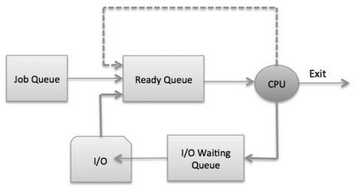

The OS can use different policies to manage each queue (FIFO, Round Robin, Priority, etc.). The OS scheduler determines how to move processes between the ready and run queues which can only have one entry per processor core on the system; in the above diagram, it has been merged with the CPU.

## Two-State Process Model

Two-state process model refers to running and non-running states which are described below −

|  |  |
| --- | --- |
| **S.N** | **State & Description** |
| 1 | **Running**  When a new process is created, it enters into the system as in the running state. |
| 2 | **Not Running**  Processes that are not running are kept in queue, waiting for their turn to execute. Each entry in the queue is a pointer to a particular process. Queue is implemented by using linked list. Use of dispatcher is as follows. When a process is interrupted, that process is transferred in the waiting queue. If the process has completed or aborted, the process is  discarded. In either case, the dispatcher then selects a process from the queue to execute. |

## Schedulers

Schedulers are special system software which handle process scheduling in various ways. Their main task is to select the jobs to be submitted into the system and to decide which process to run. Schedulers are of three types −

* Long-Term Scheduler
* Short-Term Scheduler
* Medium-Term Scheduler

## Long Term Scheduler

It is also called a **job scheduler**. A long-term scheduler determines which programs are admitted to the system for processing. It selects processes from the queue and loads them into memory for execution. Process loads into the memory for CPU scheduling.

The primary objective of the job scheduler is to provide a balanced mix of jobs, such as I/O bound and processor bound. It also controls the degree of multiprogramming. If the degree of multiprogramming is stable, then the average rate of process creation must be equal to the average departure rate of processes leaving the system.

On some systems, the long-term scheduler may not be available or minimal. Time- sharing operating systems have no long term scheduler. When a process changes the state from new to ready, then there is use of long-term scheduler.

## Short Term Scheduler

It is also called as **CPU scheduler**. Its main objective is to increase system performance in accordance with the chosen set of criteria. It is the change of ready state to running state of the process. CPU scheduler selects a process among the processes that are ready to execute and allocates CPU to one of them.

Short-term schedulers, also known as dispatchers, make the decision of which process to execute next. Short-term schedulers are faster than long-term schedulers.

## Medium Term Scheduler

Medium-term scheduling is a part of **swapping**. It removes the processes from the memory. It reduces the degree of multiprogramming. The medium-term scheduler is in-charge of handling the swapped out-processes.

A running process may become suspended if it makes an I/O request. A suspended processes cannot make any progress towards completion. In this condition, to remove the process from memory and make space for other processes, the suspended process is moved to the secondary storage. This process is called **swapping**, and the process is said to be swapped out or rolled out. Swapping may be necessary to improve the process mix.

## Comparison among Scheduler

|  |  |  |  |
| --- | --- | --- | --- |
| **S.N.** | **Long-Term Scheduler** | **Short-Term Scheduler** | **Medium-Term Scheduler** |
| 1 | It is a job scheduler | It is a CPU scheduler | It is a process swapping  scheduler. |
| 2 | Speed is lesser than short  term scheduler | Speed is fastest among  other two | Speed is in between both short  and long term scheduler. |
| 3 | It controls the degree of multiprogramming | It provides lesser control  over degree of multiprogramming | It reduces the degree of multiprogramming. |
| 4 | It is almost absent or minimal in time sharing system | It is also minimal in time sharing system | It is a part of Time sharing systems. |
| 5 | It selects processes from pool and loads them into memory for execution | It selects those processes which are ready to execute | It can re-introduce the process into memory and execution can be continued. |

**Context Switch**

A context switch is the mechanism to store and restore the state or context of a CPU in Process Control block so that a process execution can be resumed from the same point at a later time. Using this technique, a context switcher enables multiple processes to share a single CPU. Context switching is an essential part of a multitasking operating system features.

When the scheduler switches the CPU from executing one process to execute another, the state from the current running process is stored into the process control block. After this, the state for the process to run next is loaded from its own PCB and used to set the PC, registers, etc. At that point, the second process can start executing.

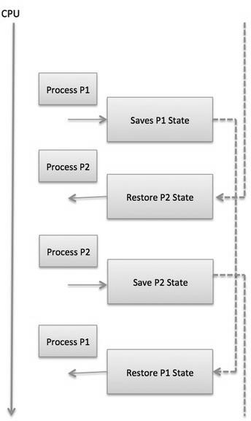

Context switches are computationally intensive since register and memory state must be saved and restored. To avoid the amount of context switching time, some hardware systems employ two or more sets of processor registers. When the process is switched, the following information is stored for later use.

* Program Counter
* Scheduling information
* Base and limit register value
* Currently used register
* Changed State
* I/O State information
* Accounting information

# Operating System scheduling algorithms

A Process Scheduler schedules different processes to be assigned to the CPU based on particular scheduling algorithms. There are six popular process scheduling algorithms which we are going to discuss in this chapter −

* First-Come, First-Served (FCFS) Scheduling
* Shortest-Job-Next (SJN) Scheduling
* Priority Scheduling
* Shortest Remaining Time
* Round Robin(RR) Scheduling
* Multiple-Level Queues Scheduling

These algorithms are either **non-preemptive or preemptive**. Non-preemptive algorithms are designed so that once a process enters the running state, it cannot be preempted until it completes its allotted time, whereas the preemptive scheduling is based on priority where a scheduler may preempt a low priority running process anytime when a high priority process enters into a ready state.

## First Come First Serve (FCFS)

* Jobs are executed on first come, first serve basis.
* It is a non-preemptive, pre-emptive scheduling algorithm.
* Easy to understand and implement.
* Its implementation is based on FIFO queue.
* Poor in performance as average wait time is high.

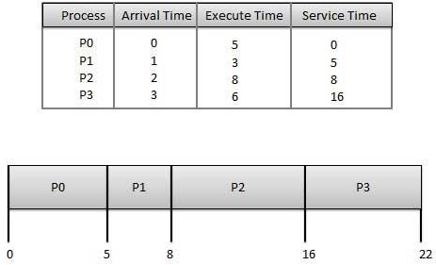

**Wait time** of each process is as follows −

|  |  |
| --- | --- |
| **Process** | **Wait Time : Service Time - Arrival Time** |
| P0 | 0 - 0 = 0 |
| P1 | 5 - 1 = 4 |
| P2 | 8 - 2 = 6 |
| P3 | 16 - 3 = 13 |

Average Wait Time: (0+4+6+13) / 4 = 5.75

## Shortest Job Next (SJN)

* This is also known as **shortest job first**, or SJF
* This is a non-preemptive, pre-emptive scheduling algorithm.
* Best approach to minimize waiting time.
* Easy to implement in Batch systems where required CPU time is known in advance.
* Impossible to implement in interactive systems where required CPU time is not known.
* The processer should know in advance how much time process will take. Given: Table of processes, and their Arrival time, Execution time

|  |  |  |  |
| --- | --- | --- | --- |
| **Process** | **Arrival Time** | **Execution Time** | **Service Time** |
| P0 | 0 | 5 | 0 |
| P1 | 1 | 3 | 5 |
| P2 | 2 | 8 | 14 |
| P3 | 3 | 6 | 8 |

**Waiting time** of each process is as follows −

|  |  |
| --- | --- |
| **Process** | **Waiting Time** |
| P0 | 0 - 0 = 0 |
| P1 | 5 - 1 = 4 |
| P2 | 14 - 2 = 12 |
| P3 | 8 - 3 = 5 |

Average Wait Time: (0 + 4 + 12 + 5)/4 = 21 / 4 = 5.25

## Priority Based Scheduling

* Priority scheduling is a non-preemptive algorithm and one of the most common scheduling algorithms in batch systems.
* Each process is assigned a priority. Process with highest priority is to be executed first and so on.
* Processes with same priority are executed on first come first served basis.
* Priority can be decided based on memory requirements, time requirements or any other resource requirement.

Given: Table of processes, and their Arrival time, Execution time, and priority. Here we are considering 1 is the lowest priority.

|  |  |  |  |  |
| --- | --- | --- | --- | --- |
| **Process** | **Arrival Time** | **Execution Time** | **Priority** | **Service Time** |
| P0 | 0 | 5 | 1 | 0 |
| P1 | 1 | 3 | 2 | 11 |
| P2 | 2 | 8 | 1 | 14 |
| P3 | 3 | 6 | 3 | 5 |

**Waiting time** of each process is as follows −

|  |  |
| --- | --- |
| **Process** | **Waiting Time** |
| P0 | 0 - 0 = 0 |
| P1 | 11 - 1 = 10 |
| P2 | 14 - 2 = 12 |
| P3 | 5 - 3 = 2 |

Average Wait Time: (0 + 10 + 12 + 2)/4 = 24 / 4 = 6

## Shortest Remaining Time

* Shortest remaining time (SRT) is the preemptive version of the SJN algorithm.
* The processor is allocated to the job closest to completion but it can be preempted by a newer ready job with shorter time to completion.
* Impossible to implement in interactive systems where required CPU time is not known.
* It is often used in batch environments where short jobs need to give preference.

## Round Robin Scheduling

* Round Robin is the preemptive process scheduling algorithm.
* Each process is provided a fix time to execute, it is called a **quantum**.
* Once a process is executed for a given time period, it is preempted and other process executes for a given time period.
* Context switching is used to save states of preempted processes.

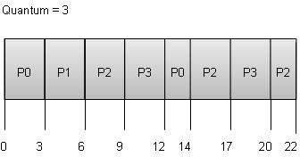

**Wait time** of each process is as follows −

|  |  |
| --- | --- |
| **Process** | **Wait Time : Service Time - Arrival Time** |
| P0 | (0 - 0) + (12 - 3) = 9 |
| P1 | (3 - 1) = 2 |
| P2 | (6 - 2) + (14 - 9) + (20 - 17) = 12 |
| P3 | (9 - 3) + (17 - 12) = 11 |

Average Wait Time: (9+2+12+11) / 4 = 8.5

## Multiple-Level Queues Scheduling

Multiple-level queues are not an independent scheduling algorithm. They make use of other existing algorithms to group and schedule jobs with common characteristics.

* Multiple queues are maintained for processes with common characteristics.
* Each queue can have its own scheduling algorithms.
* Priorities are assigned to each queue.

For example, CPU-bound jobs can be scheduled in one queue and all I/O-bound jobs in another queue. The Process Scheduler then alternately selects jobs from each queue and assigns them to the CPU based on the algorithm assigned to the queue.

# Operating System - Memory Management

Memory management is the functionality of an operating system which handles or manages primary memory and moves processes back and forth between main memory and disk during execution. Memory management keeps track of each and every memory location, regardless of either it is allocated to some process or it is free. It checks how much memory is to be allocated to processes. It decides which process will get memory at what time. It tracks whenever some memory gets freed or unallocated and correspondingly it updates the status.

This tutorial will teach you basic concepts related to Memory Management.

## Process Address Space

The process address space is the set of logical addresses that a process references in its code. For example, when 32-bit addressing is in use, addresses can range from 0 to 0x7fffffff; that is, 2^31 possible numbers, for a total theoretical size of 2 gigabytes.

The operating system takes care of mapping the logical addresses to physical addresses at the time of memory allocation to the program. There are three types of addresses used in a program before and after memory is allocated −

|  |  |
| --- | --- |
| **S.N.** | **Memory Addresses & Description** |
| 1 | **Symbolic addresses**  The addresses used in a source code. The variable names, constants, and instruction labels are the basic elements of the symbolic address space. |
| 2 | **Relative addresses**  At the time of compilation, a compiler converts symbolic addresses into relative addresses. |

|  |  |
| --- | --- |
| 3 | **Physical addresses**  The loader generates these addresses at the time when a program is loaded into main memory. |

Virtual and physical addresses are the same in compile-time and load-time address-binding schemes. Virtual and physical addresses differ in execution-time address-binding scheme.

The set of all logical addresses generated by a program is referred to as a **logical address space**. The set of all physical addresses corresponding to these logical addresses is referred to as a **physical address space.**

The runtime mapping from virtual to physical address is done by the memory management unit (MMU) which is a hardware device. MMU uses following mechanism to convert virtual address to physical address.

* The value in the base register is added to every address generated by a user process, which is treated as offset at the time it is sent to memory. For example, if the base register value is 10000, then an attempt by the user to use address location 100 will be dynamically reallocated to location 10100.
* The user program deals with virtual addresses; it never sees the real physical addresses.

## Static vs Dynamic Loading

The choice between Static or Dynamic Loading is to be made at the time of computer program being developed. If you have to load your program statically, then at the time of compilation, the complete programs will be compiled and linked without leaving any external program or module dependency. The linker combines the object program with other necessary object modules into an absolute program, which also includes logical addresses.

If you are writing a Dynamically loaded program, then your compiler will compile the program and for all the modules which you want to include dynamically, only references will be provided and rest of the work will be done at the time of execution.

At the time of loading, with **static loading**, the absolute program (and data) is loaded into memory in order for execution to start.

If you are using **dynamic loading**, dynamic routines of the library are stored on a disk in relocatable form and are loaded into memory only when they are needed by the program.

## Static vs Dynamic Linking

As explained above, when static linking is used, the linker combines all other modules needed by a program into a single executable program to avoid any runtime dependency.

When dynamic linking is used, it is not required to link the actual module or library with the program, rather a reference to the dynamic module is provided at the time of compilation and linking. Dynamic Link Libraries (DLL) in Windows and Shared Objects in Unix are good examples of dynamic libraries.

**Swapping**

Swapping is a mechanism in which a process can be swapped temporarily out of main memory (or move) to secondary storage (disk) and make that memory available to other processes. At some later time, the system swaps back the process from the secondary storage to main memory.

Though performance is usually affected by swapping process but it helps in running multiple and big processes in parallel and that's the reason **Swapping is also known as a technique for memory compaction**.

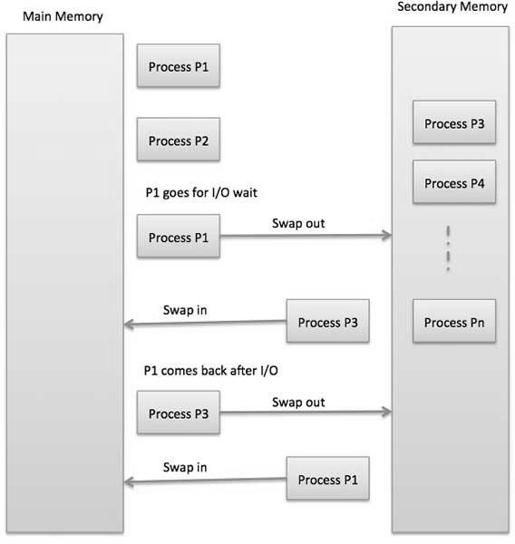

The total time taken by swapping process includes the time it takes to move the entire process to a secondary disk and then to copy the process back to memory, as well as the time the process takes to regain main memory.

## Memory Allocation

Main memory usually has two partitions −

* **Low Memory** − Operating system resides in this memory.
* **High Memory** − User processes are held in high memory. Operating system uses the following memory allocation mechanism.

|  |  |
| --- | --- |
| **S.N.** | **Memory Allocation & Description** |

|  |  |
| --- | --- |
| 1 | **Single-partition allocation**  In this type of allocation, relocation-register scheme is used to protect user processes from each other, and from changing operating-system code and data. Relocation register contains value of smallest physical address whereas limit register contains range of logical addresses. Each logical address must be less than the limit register. |
| 2 | **Multiple-partition allocation**  In this type of allocation, main memory is divided into a number of fixed-sized partitions where each partition should contain only one process. When a partition is free, a process is selected from the input queue and is loaded into the free partition. When the process terminates, the partition becomes available for another process. |

**Fragmentation**

As processes are loaded and removed from memory, the free memory space is broken into little pieces. It happens after sometimes that processes cannot be allocated to memory blocks considering their small size and memory blocks remains unused. This problem is known as Fragmentation.

Fragmentation is of two types −

|  |  |
| --- | --- |
| **S.N.** | **Fragmentation & Description** |
| 1 | **External fragmentation**  Total memory space is enough to satisfy a request or to reside a process in it, but it is not contiguous, so it cannot be used. |
| 2 | **Internal fragmentation**  Memory block assigned to process is bigger. Some portion of memory is left unused, as it cannot be used by another process. |

The following diagram shows how fragmentation can cause waste of memory and a compaction technique can be used to create more free memory out of fragmented memory −

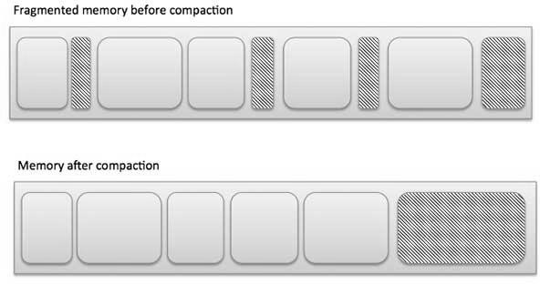

External fragmentation can be reduced by compaction or shuffle memory contents to place all free memory together in one large block. To make compaction feasible, relocation should be dynamic.

The internal fragmentation can be reduced by effectively assigning the smallest partition but large enough for the process.

## Paging

A computer can address more memory than the amount physically installed on the system. This extra memory is actually called virtual memory and it is a section of a hard that's set up to emulate the computer's RAM. Paging technique plays an important role in implementing virtual memory.

Paging is a memory management technique in which process address space is broken into blocks of the same size called **pages** (size is power of 2, between 512 bytes and 8192 bytes). The size of the process is measured in the number of pages.

Similarly, main memory is divided into small fixed-sized blocks of (physical) memory called **frames** and the size of a frame is kept the same as that of a page to have optimum utilization of the main memory and to avoid external fragmentation.

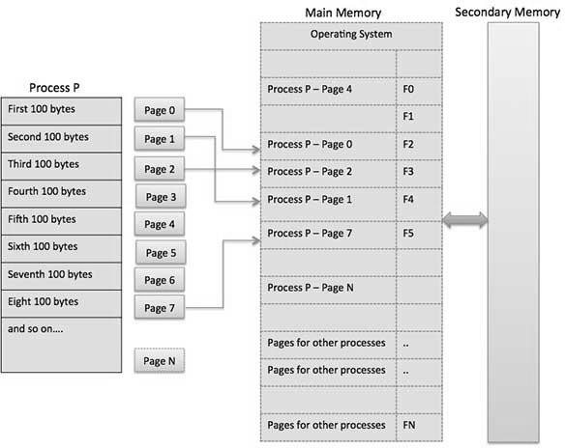

Address Translation

Page address is called **logical address** and represented by **page number** and the **offset**. Logical Address = Page number + page offset

Frame address is called **physical address** and represented by a **frame number** and the **offset**. Physical Address = Frame number + page offset

A data structure called **page map table** is used to keep track of the relation between a page of a process to a frame in physical memory.

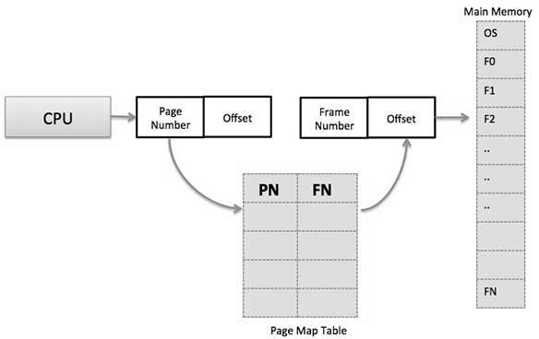

When the system allocates a frame to any page, it translates this logical address into a physical address and create entry into the page table to be used throughout execution of the program.

When a process is to be executed, its corresponding pages are loaded into any available memory frames. Suppose you have a program of 8Kb but your memory can accommodate only

5Kb at a given point in time, then the paging concept will come into picture. When a computer runs out of RAM, the operating system (OS) will move idle or unwanted pages of memory to secondary memory to free up RAM for other processes and brings them back when needed by the program.

This process continues during the whole execution of the program where the OS keeps removing idle pages from the main memory and write them onto the secondary memory and bring them back when required by the program.

## Advantages and Disadvantages of Paging

Here is a list of advantages and disadvantages of paging −

* Paging reduces external fragmentation, but still suffer from internal fragmentation.
* Paging is simple to implement and assumed as an efficient memory management technique.
* Due to equal size of the pages and frames, swapping becomes very easy.
* Page table requires extra memory space, so may not be good for a system having small RAM.

**Segmentation**

Segmentation is a memory management technique in which each job is divided into several segments of different sizes, one for each module that contains pieces that perform related functions. Each segment is actually a different logical address space of the program.

When a process is to be executed, its corresponding segmentation are loaded into non- contiguous memory though every segment is loaded into a contiguous block of available memory.

Segmentation memory management works very similar to paging but here segments are of variable-length where as in paging pages are of fixed size.

A program segment contains the program's main function, utility functions, data structures, and so on. The operating system maintains a **segment map table** for every process and a list of free memory blocks along with segment numbers, their size and corresponding memory locations in main memory. For each segment, the table stores the starting address of the segment and the length of the segment. A reference to a memory location includes a value that identifies a segment and an offset.

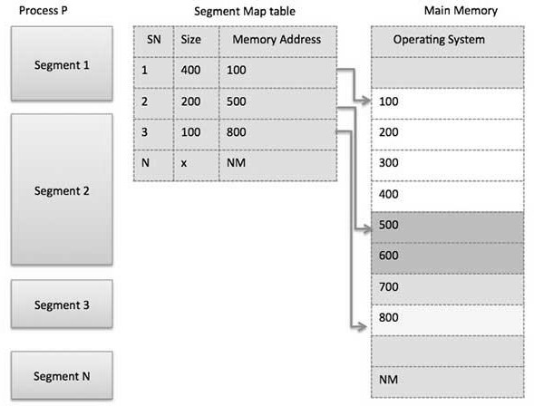

## Virtual Memory

A computer can address more memory than the amount physically installed on the system. This extra memory is actually called **virtual memory** and it is a section of a hard disk that's set up to emulate the computer's RAM.

The main visible advantage of this scheme is that programs can be larger than physical memory. Virtual memory serves two purposes. First, it allows us to extend the use of physical memory by using disk. Second, it allows us to have memory protection, because each virtual address is translated to a physical address.

Following are the situations, when entire program is not required to be loaded fully in main memory.

* User written error handling routines are used only when an error occurred in the data or computation.
* Certain options and features of a program may be used rarely.
* Many tables are assigned a fixed amount of address space even though only a small amount of the table is actually used.
* The ability to execute a program that is only partially in memory would counter many benefits.
* Less number of I/O would be needed to load or swap each user program into memory.
* A program would no longer be constrained by the amount of physical memory that is available.
* Each user program could take less physical memory, more programs could be run the same time, with a corresponding increase in CPU utilization and throughput.

Modern microprocessors intended for general-purpose use, a memory management unit, or MMU, is built into the hardware. The MMU's job is to translate virtual addresses into physical addresses. A basic example is given below −

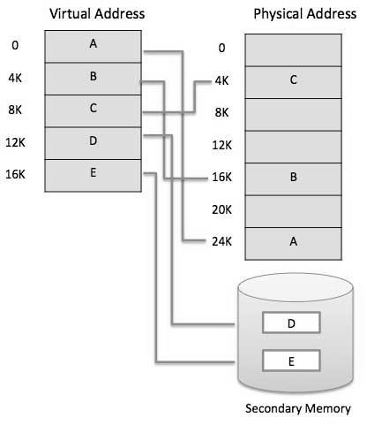

Virtual memory is commonly implemented by demand paging. It can also be implemented in a segmentation system. Demand segmentation can also be used to provide virtual memory.

**Demand Paging**

A demand paging system is quite similar to a paging system with swapping where processes reside in secondary memory and pages are loaded only on demand, not in advance. When a context switch occurs, the operating system does not copy any of the old program’s pages out to the disk or any of the new program’s pages into the main memory Instead, it just begins executing the new program after loading the first page and fetches that program’s pages as they are referenced.

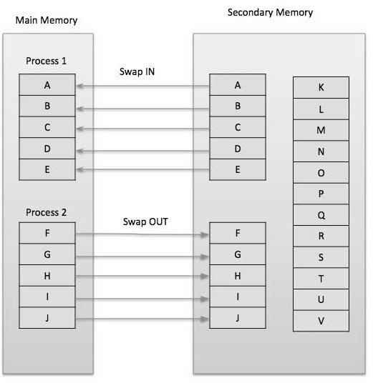

While executing a program, if the program references a page which is not available in the main memory because it was swapped out a little ago, the processor treats this invalid memory reference as a **page fault** and transfers control from the program to the operating system to demand the page back into the memory.

### Advantages

Following are the advantages of Demand Paging −

* Large virtual memory.
* More efficient use of memory.
* There is no limit on degree of multiprogramming.

### Disadvantages

* Number of tables and the amount of processor overhead for handling page interrupts are greater than in the case of the simple paged management techniques.